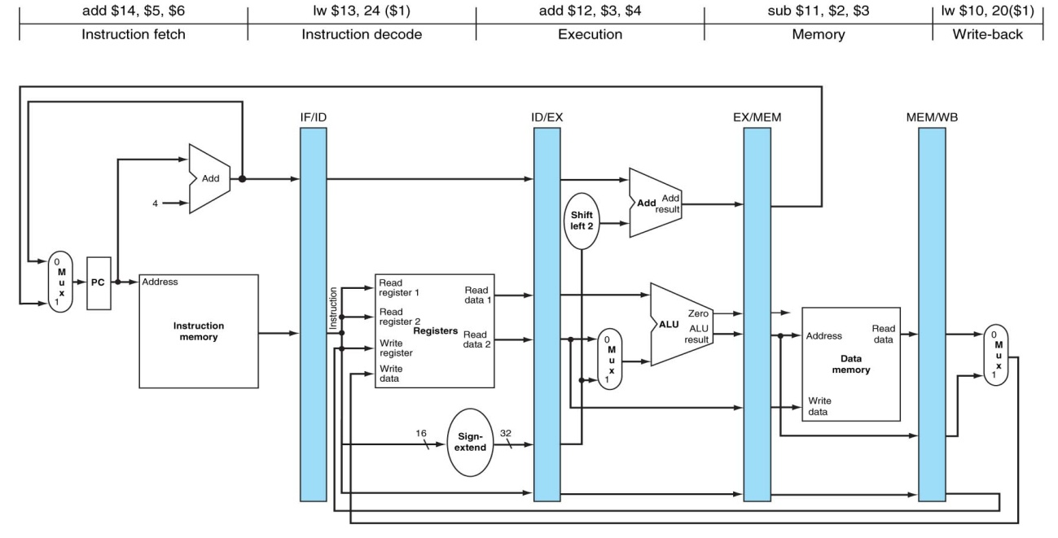

ENUNCIADO **PROBLEMA 3**:

**$7** = 4

**$1** = 16

**$2** = 10

**$6** = 1000

**MEM[44]** = 200

**Método utilizado para resolver los riesgos de datos**: bloqueo, anticipación.

|  |  |  |  |  |  |  |  |  |  |
| --- | --- | --- | --- | --- | --- | --- | --- | --- | --- |
|  | **Ciclo 1** | **Ciclo 2** | **Ciclo 3** | **Ciclo 4** | **Ciclo 5** | **Ciclo 6** | **Ciclo 7** | **Ciclo 8** | **Ciclo 9** |
|  | 16 | 16 | 16 | 16 | 16/200 | 200 | 200 | 200 |  |
|  | X | X | X | X | X | X | X | X/200 |  |
|  | X | X | X | 44 | 44 | 208 | 20 | 20 |  |
|  | X | X | X | X | 200 | 200 | 200 | 20 |  |
| **LW $1, 40($7)** | MI | REG  ID/EX1🡨40  ID/EX2🡨4 | ALU  EX/MEM🡨ID/EX1+  ID/EX2=40+4=44 | MD  MEM/WB🡨  MD[EX/MEM]=  MD[44]=200 | REG  $1🡨MEM/WB=200 |  |  |  |  |
| **SW $6, 8($1)** |  | MI | REG  ID/EX1=8  ID/EX2=16  ID/EX3=1000 | --- | ALU  EX/MEM1🡨ID/EX1+  MEM/WB=8+200=208 | MD  MD[EX/MEM1]=  MD[208]🡨EX/MEM2  =1000 | --- |  |  |
| **ADD $9, $2, $2** |  |  | MI | --- | REG  ID/EX1🡨10  ID/EX2🡨10 | ALU  EX/MEM🡨ID/EX1+  ID/EX2=10+10=20 | MD  MEM/WB🡨  EX/MEM=20 | REG  $9🡨MEM/WB=20 |  |
| **Comentarios** |  |  | $1 No contiene el valor esperado. |  | Anticipación del resultado desde MEM/WB |  |  |  |  |